
SHIRE HIGHLANDS EDUCATION DIVISION
2025 MALAWI SCHOOL CERTIFICATE OF EDUCATION MOCK
EXAMINATION

GEOGRAPHY
Subject Number: M073/I
Tuesday, 1st April, Time Allowed: 2 hours 30 mins
8:00-10:30am

PAPER I
(100 Marks)

MAP READING AND PHYSICAL GEOGRAPHY

Instructions
Question number | Tick if answered | Do not write in these columns
1
2
3
4
5
- This paper contains 10 printed pages. Please check.

- There are five questions in this paper.
- There are two sections A and B.
- Section A comprises of three questions and candidates must answer all the three questions.

- Section B comprises of two questions and candidates must answer one question only.

- Write your Name and school on top of the question paper.

- In the table provided on this page, tick against
the question numbers you have answered.

Turn over…../
Section A (75 marks)
1. Study the 1:50,000 map extract of Zomba Sheet 1535B3 and answer the questions that follow:
a. i. Find the six figure grid reference for trigonometrical station 629 at Kachulu.
________________________________________________________________ (2 marks)
ii. Identify the human feature found on grid reference 723966.
________________________________________________________________ (2 marks)
b. i. Calculate the bearing of trigonometrical station 629 from trigonometrical station 1056.
________________________________________________________________ (2 marks)
ii. Find the direction of Mchenga in grid box 7700 village from Kachoka village in grid box 7698.
________________________________________________________________ (2 marks)
c. Measure the distance of S143 road from easting 70 on the western side up to where it crosses easting 76. Present your answer to the nearest kilometre.
__________________________________________________________________ (2 marks)
d. Calculate the area covered by the land between the western side of easting 73 and northern part of northing 00.

5 marks
e. Calculate gradient along S143 road from easting 70 to where it crosses easting 73. Change feet to metres

(7 marks)
f. Account for the absence of settlements in the areas close to the lake.
______________________________________________________________________________________________________________________________________________(2 marks)
g. Suggest a reason why several areas on the map have rice schemes.
____________________________________________________________________(1 mark)

2. a. i. Define the term air mass.
_________________________________________________________________________________________________________________________________________(1 mark)
ii. Explain briefly the following terms related to air masses:
Unstable airmass
________________________________________________________________________________________________________________________________________________________________________________________________________________ (2 marks)
Occluded front
________________________________________________________________________________________________________________________________________________________________________________________________________________ (2 marks)
b. Figure 1 is a diagram showing major tectonic plates of the world. Use it to answer questions 2 b. i, ii, iii and iv.
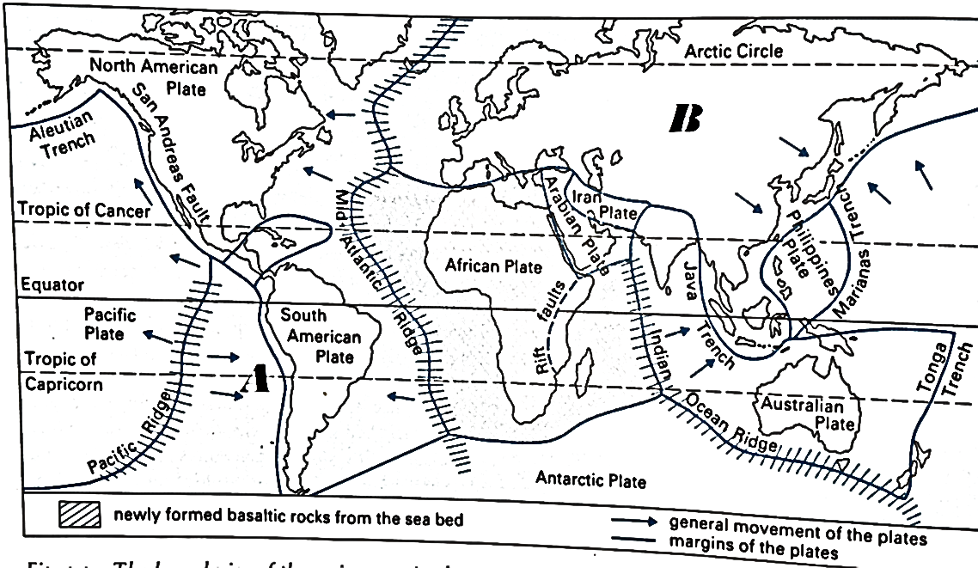
i. Identify the tectonic plates labelled A and B.
A___________________________________________________________________B____________________________________________________________(2 marks)
ii. Name any one feature formed as a result of the convergence of plate labelled A and South
American plate.
_________________________________________________________________ (1 mark)
iii. Using plate tectonics theory, explain how the Mid Atlantic Ridge was formed.
_____________________________________________________________________________________________________________________________________________________________________________________________________________________________________________________________________________________(3 marks)
iv. Explain briefly how the San Andreas fault shown on the map was formed.
_______________________________________________________________________________________________________________________________________(2 marks)
c. i. Mention any one example of high clouds.
_________________________________________________________________(1 mark)
ii. Give any two characteristics of cumulonimbus clouds.
_________________________________________________________________________________________________________________________________________(2 marks)
iii. Explain any two ways in which clouds are important.
________________________________________________________________________________________________________________________________________________________________________________________________________________________________________________________________________________________ (4 marks)
d. Figure 2 is a diagram showing a type of delta. Use it to answer the questions that follow:
Delta

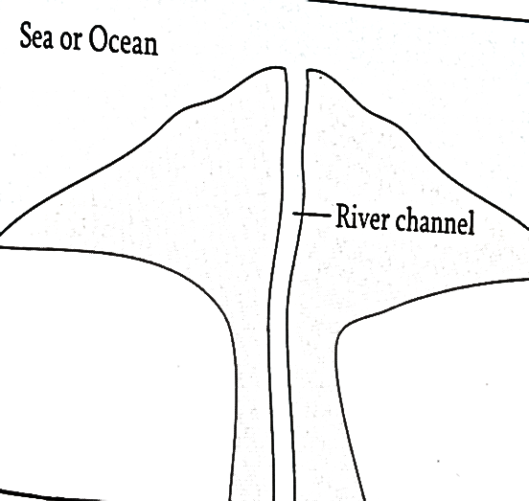
- Identify the type of delta shown in figure 2 above.
_________________________________________________________________ (1 mark)
ii. Explain briefly how this type of delta is formed.
________________________________________________________________________________________________________________________________________ (3 marks)
iii. Mention any one economic importance of deltas.
________________________________________________________________ (1 mark)
3. a. i. Define the term “earthquake”
_________________________________________________________________________________________________________________________________________(1 mark)
ii. Explain the relationship between volcanic activity and earthquakes.
________________________________________________________________________________________________________________________________________ (2 marks)
b. Figure 3 is a diagram showing a weather feature. Use it to answer questions that follow.
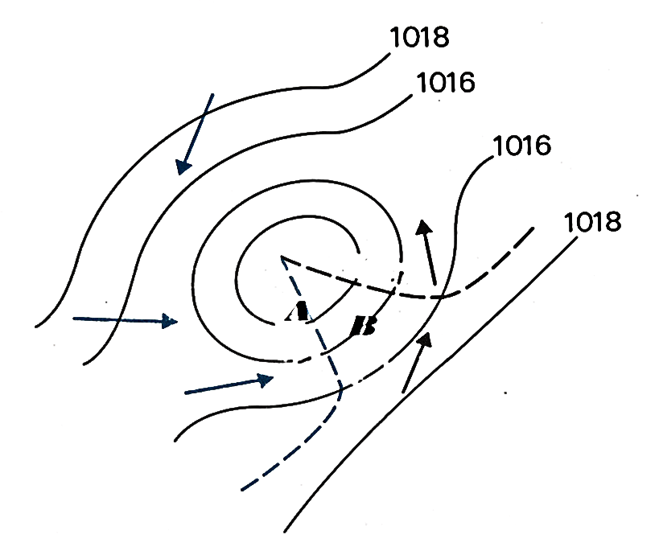
i. Identify the weather feature shown in figure 3 above.
_________________________________________________________________ (1 mark)
ii. Give the name for the feature labelled A.
_________________________________________________________________ (1 mark)
iii. Give any two weather conditions associated with the area labelled B.
_______________________________________________________________________________________________________________________________________(2 marks)
c. i. Define the term “folding”
_________________________________________________________________________________________________________________________________________(1 mark)
ii. Draw a diagram to illustrate a simple fold.

2 marks
d. Figure 4 is map of the world showing ocean currents. Use it to answer the questions that follow;
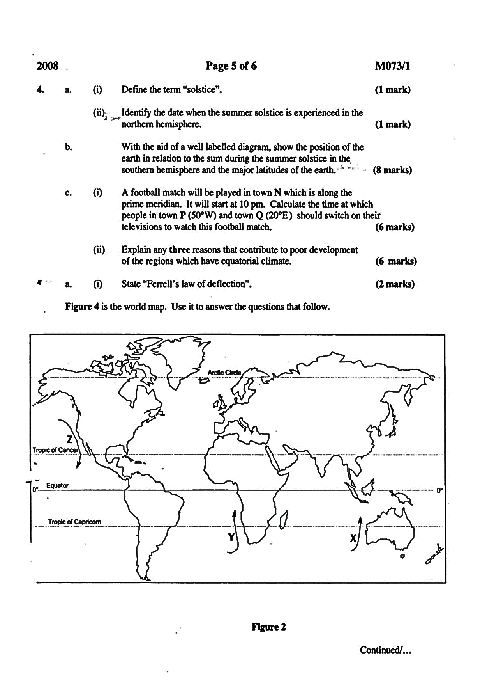
- Draw arrows on the map to illustrate position and direction of the following ocean currents:
Peruvian ocean current (1 mark)
Canaries ocean current (1 mark)
- Mention the deserts formed as a result of the following ocean currents:
Ocean current X ________________________________________________ (1 mark)
Ocean current Y________________________________________________ (1 mark)
Ocean current Z_________________________________________________ (1 mark)
- Explain how the following factors influence the direction of ocean currents:
Prevailing wind __________________________________________________________________________________________________________________________________ (2 marks)
Shape of continents __________________________________________________________________________________________________________________________________(2 marks)
e. i. Define the term climate change. ______________________________________________________________________________________________________________________________________(1mark)
ii. Explain the relationship between climate change and the following:
Flooding
____________________________________________________________________________________________________________________________________ (2 marks)
Cyclones
____________________________________________________________________________________________________________________________________ (2 marks)
iii. Give any one climate change adaptation measure.
______________________________________________________________(1 mark)

SECTION B (25 MARKS)
Choose any one question from this section.
4. a. i. Describe a continental shelf
___________________________________________________________________________________________________________________________________________(2 marks)
ii. Explain any two ways in which a continental shelf is of economic importance.
______________________________________________________________________________________________________________________________________________________________________________________________________________________________________________________________________________________________________________________________________________________________________(4 marks)
b. Figure 5 is a diagram that shows climatic data of rainfall and temperature for a certain weather station. Use it to answer questions 4 b. i, ii, iii and iv.
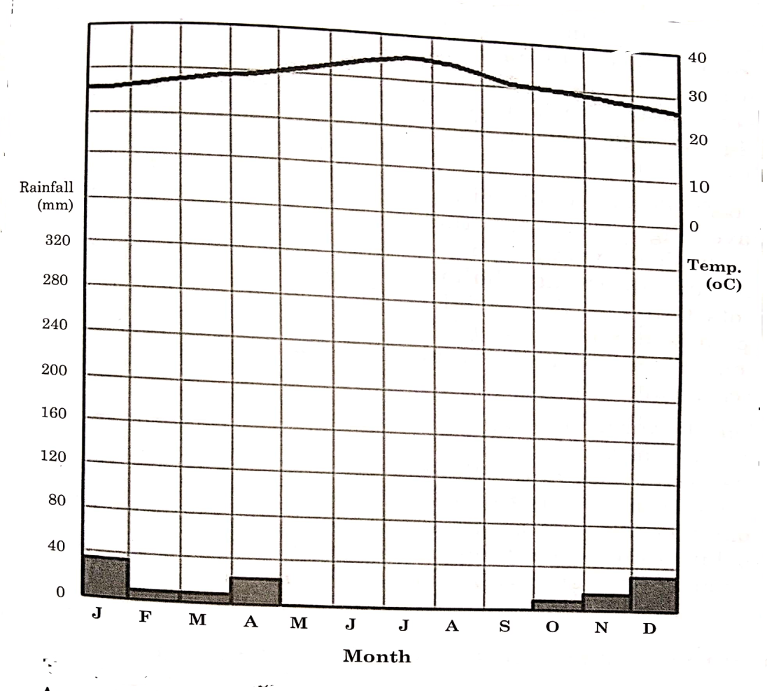
i. Identify the climatic region in which this weather station is located.
_________________________________________________________________(1 mark)
ii. Explain how vegetation in the climate mentioned in 4 b. i. above is adapted to the conditions.
_________________________________________________________________________________________________________________________________________________________________________________________________________________________________________________________________________________________(4 marks)
iii. Explain any two economic activities that take place in the climatic region mentioned in 4. b. i. _________________________________________________________________________________________________________________________________________________________________________________________________________________________________________________________________________________________________________________________________________________________________(4 marks)
iv. Explain any two factors that limit development in the climatic region mentioned in 4. b i. above.
_________________________________________________________________________________________________________________________________________________________________________________________________________________________________________________________________________________________(4 marks)
c. i. Explain briefly how volcanic activity can lead to the following:
Geothermal energy
_________________________________________________________________________________________________________________________________________(2 marks)
Tourism
_________________________________________________________________________________________________________________________________________(2 marks)
ii. Give any one disadvantage of vulcanicity.
_________________________________________________________________ (1 mark)
iii. Mention any one volcanic mountain in Africa.
_________________________________________________________________ (1 mark)
5. a. i. Describe briefly the following terms related to continental drift theory:
Gondwanaland
___________________________________________________________________________________________________________________________________________(2 marks)
Pangea
___________________________________________________________________________________________________________________________________________(2 marks)
ii. Explain any two evidences of Alfred Wegener that support continental drift theory.
_____________________________________________________________________________________________________________________________________________________________________________________________________________________________________________________________________________________________(4 marks)
b. Figure 6 is a picture showing a certain type of vegetation. Use it to answer the questions 5 b. i, ii, iii and iv.
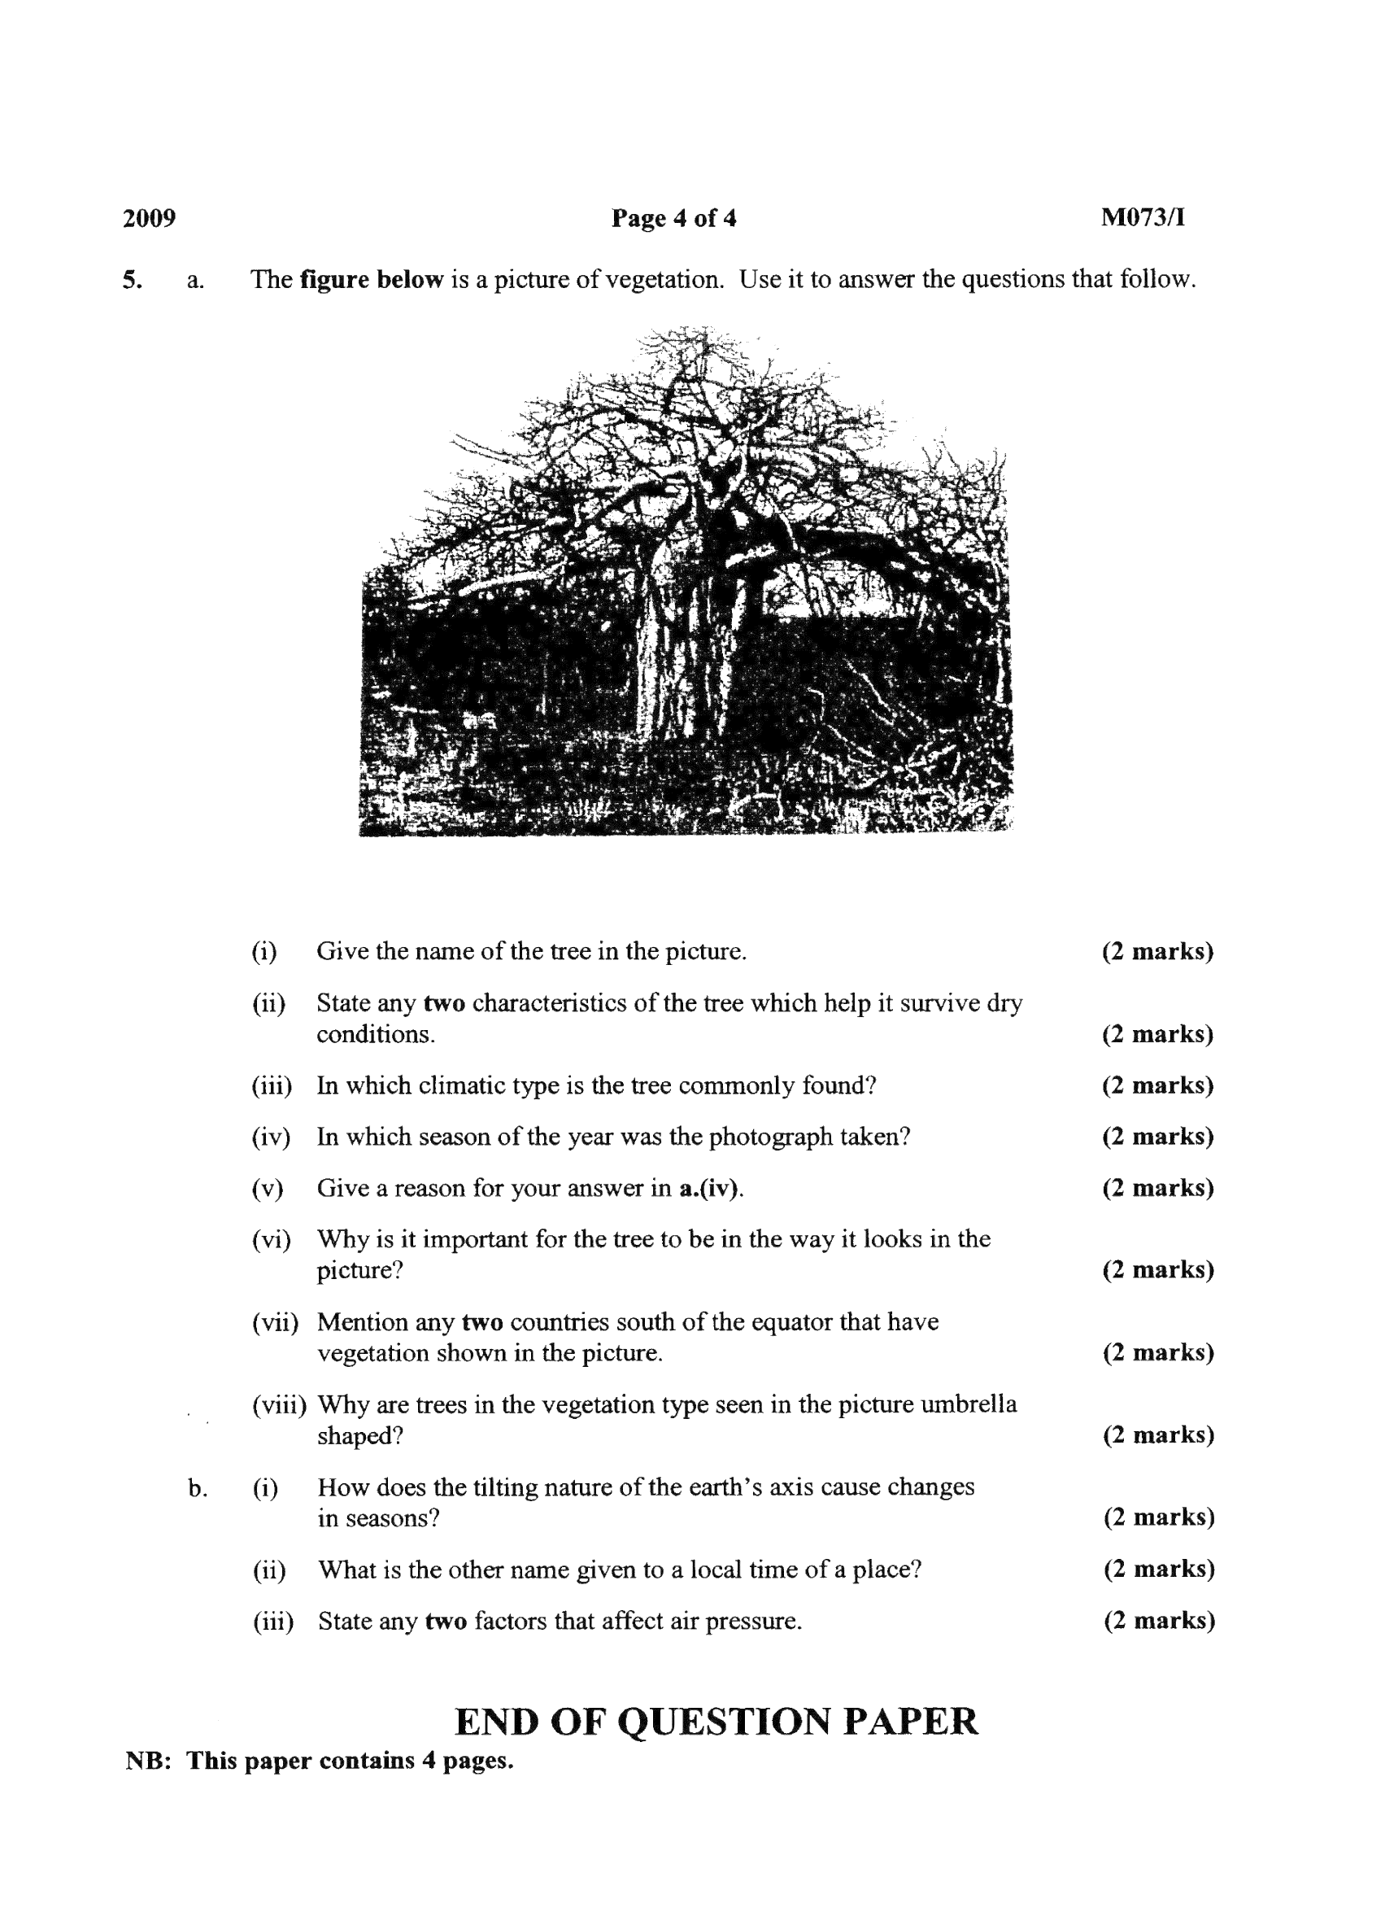
i. Identify the climatic region you are likely to find this type of vegetation.
___________________________________________________________________(1 mark)
ii. Explain any two adaptations of the plant that help it to survive dry conditions.
_____________________________________________________________________________________________________________________________________________________________________________________________________________________________________________________________________________________________(4 marks)
iii. In which season of the year was the photograph taken.
___________________________________________________________________(1 mark)
- Explain any two factors that limit agricultural development in the climatic region mentioned in 5 b. i. above.
___________________________________________________________________________________________________________________________________________________________________________________________________________________________________________________________________________________________________ (4 marks)
c. i. Explain why the equatorial region is an area of low pressure.
_____________________________________________________________________________________________________________________________________________ (2 marks)
ii. Give any two characteristics of trade winds.
_____________________________________________________________________________________________________________________________________________ (2 marks)
d. i. State any two characteristics of igneous rocks.
___________________________________________________________________________________________________________________________________________(2 marks)
ii. Mention any one way in which rocks are beneficial to human beings.
___________________________________________________________________________________________________________________________________________(1 marks)

END OF QUESTION PAPER

